

Instructions for

Dual Transducer Scanning

Hawaii Specific

05/16/2017

Daniel Gross

212.502.1781

dgross@riversideresearch.org

Contents

STARTING THE SYSTEM **Error! Bookmark not defined.**

LOADING THE SOFTWARE 3

FILE NAMING CONVENTION 4

SETTING UP THE ACQUISITION WINDOW 5

REAL TIME WINDOW: AN OVERVIEW 5

ACQUIRING DATA 7

REVIEWING AND SAVING THE DATA 8

## LOADING THE SOFTWARE

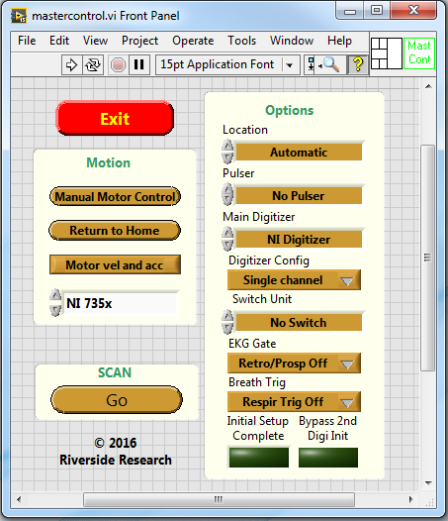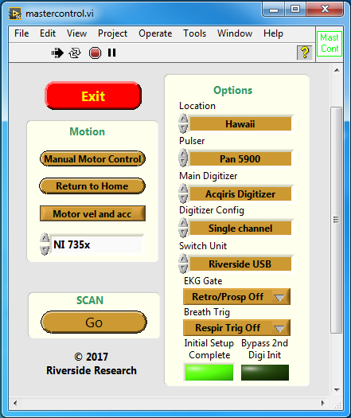

C) Go Button

B) Location Control

A) Run Arrow

D) Initial Setup Complete

Figure 1: MasterControl.vi Front Panel before and immediately after starting the program

1. Open Master Control from the desktop

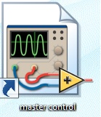

1. Insure the Location is: Automatic or Hawaii (Figure 1B)
2. Click the run arrow (Figure 1A)
   1. Defaults will populate, and the Initial Setup Complete indicator will light up (Figure 1D)
3. Place the water tank on the platform with the manually raised transducers
4. Click the GO button (Figure 1C)

## FILE NAMING CONVENTION

1. The file name uses the format TTTLPPPNNNT, where:

TT: Lymph Node (LN)

TL: Tissue Location (Br - Breast, Ga - Gastric, Co - Colon, Re – Rectal, HN – Head and Neck)

PPP: Patient Number

NN: Node Number (01)

NT: Node Type (OA – Whole Node, SA – Sentinel A, SB – Sentinel B, SC – Sentinel C)

Example: LNBr33301OA

Meaning of Example:

/Lymph Node/Breast/Patient 333/Lymph Node 01/Whole Lymph Node

1. The File Name should auto-generate, but it cannot always predict what the experimental conditions are; if it is incorrect, click the Generate New File Name button and correct the fields (Figure 3E)

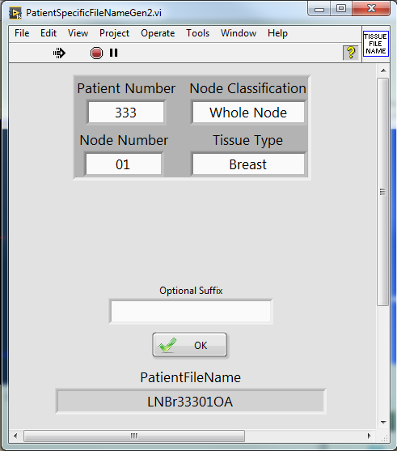

Figure : File Name Generation Program

## SETTING UP THE ACQUISITION WINDOW

1. Use the RIGHT arrow key of the keyboard to move the X-axis until the lymph node is no longer visible on the screen
2. Click End Point Marker or press Enter (Figure 3A)
3. Using the LEFT arrow key, repeat steps 4 and 5 for the other end of the sample
4. Click Center or press Space Bar (Figure 3B)
5. Use the mouse to drag the Blue (Figure 3C) and White (Figure 3D) cursors to just outside of the sample.

## REAL TIME WINDOW: AN OVERVIEW

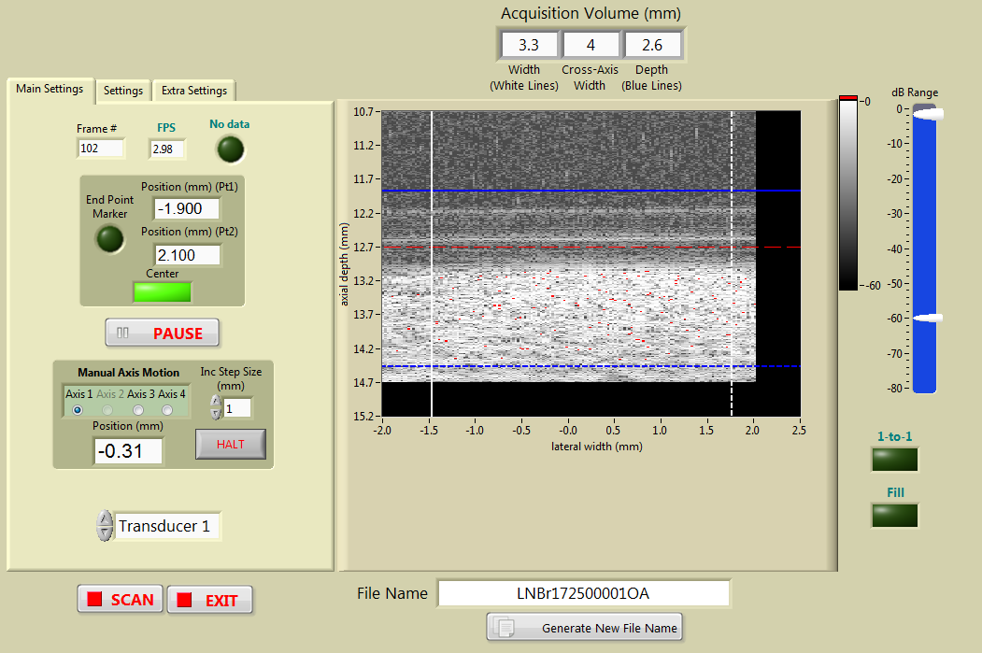

D) White Cursors

C) Blue Cursors

Transducer Select

A) End Point Marker

E) New File Name

Pause Scanning

Scan or Exit

B) Center

Figure 3: The real-time scan window

FINE TUNING THE ACQUISITION WINDOW

A) Tab Controls

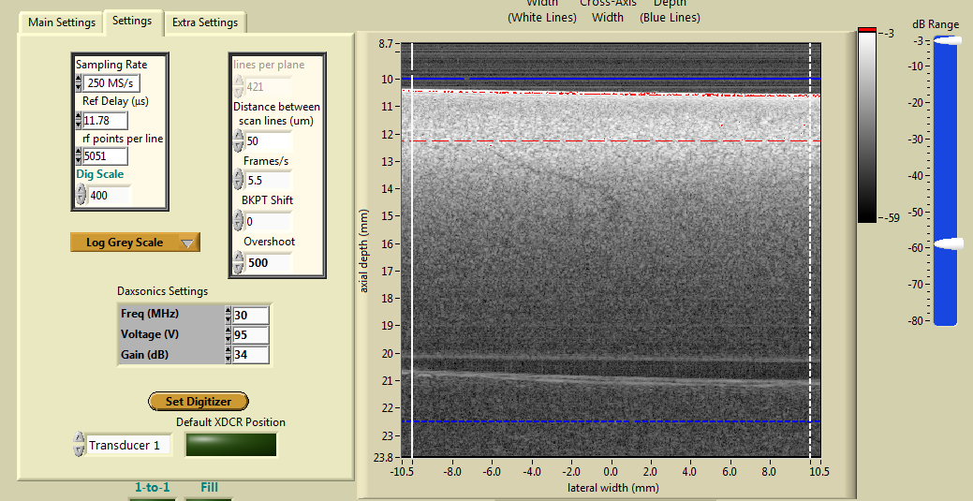

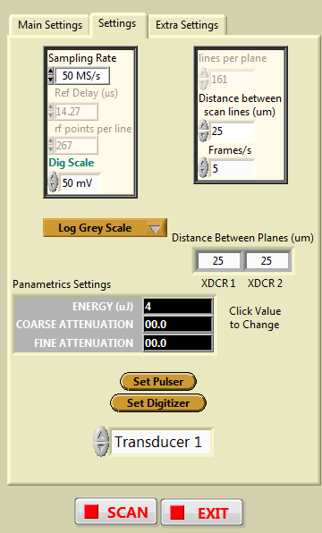

B) Saturation

C) Pulser Settings

Figure 4: Adjusting the Pulser

1. **Pulser settings must be checked for both transducers independently**
2. Click the Settings Tab (Figure 3A)
3. Saturation is displayed as red points overlaying the Raw Data image (Figure 4B)
4. Helpful Hints
   1. Saturation is permissible in the fat or capsule
   2. If you find that you are consistently changing the settings to the same value, you can store the new settings as default by clicking Save Dual Transducer Settings in the Extra Settings Tab

## ACQUIRING DATA

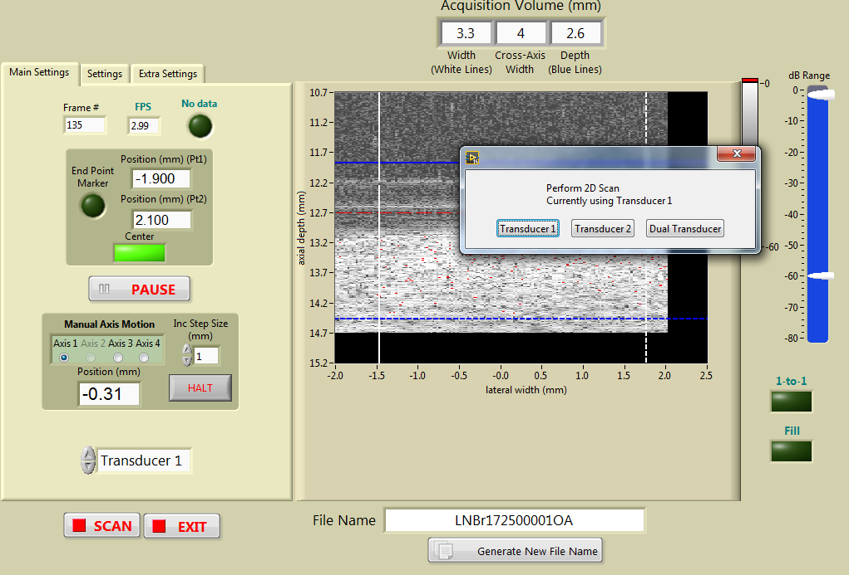

B) Dual or Single scan selection

A) Scan

Figure 5: Starting data collection

1. Clicking the SCAN (Figure 5A) button opens a dialogue box prompting you to scan with either transducer, both transducers, or by clicking the red X button returning to the setup program (Figure 5B)
2. The transducer and sample will move to the starting position and commence scanning
3. Scanning can be stopped at any time by clicking the STOP SCAN button (Figure 6A).

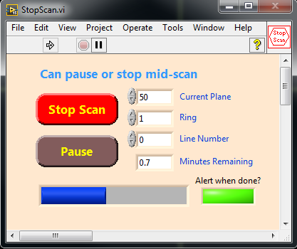

Alert Tone when Finished

Time Remaining

A) Scan

Figure 6: Scan Progress Window

## REVIEWING AND SAVING THE DATA

1. The data will be displayed on the screen, possibly with incorrect scaling
2. Click the X or Y buttons, or use the X or Y keyboard keys, to rescale the image in X or Y (Figure 7E)
3. Click the Case to View pull-down menu, or the UP and DOWN keys, to select amongst the scan sets that have not yet been saved (Figure 7B)
4. Increment or type in a value in Scan to View, or use the LEFT or RIGHT keys, to view amongst the scans in Case to View (Figure 7C)

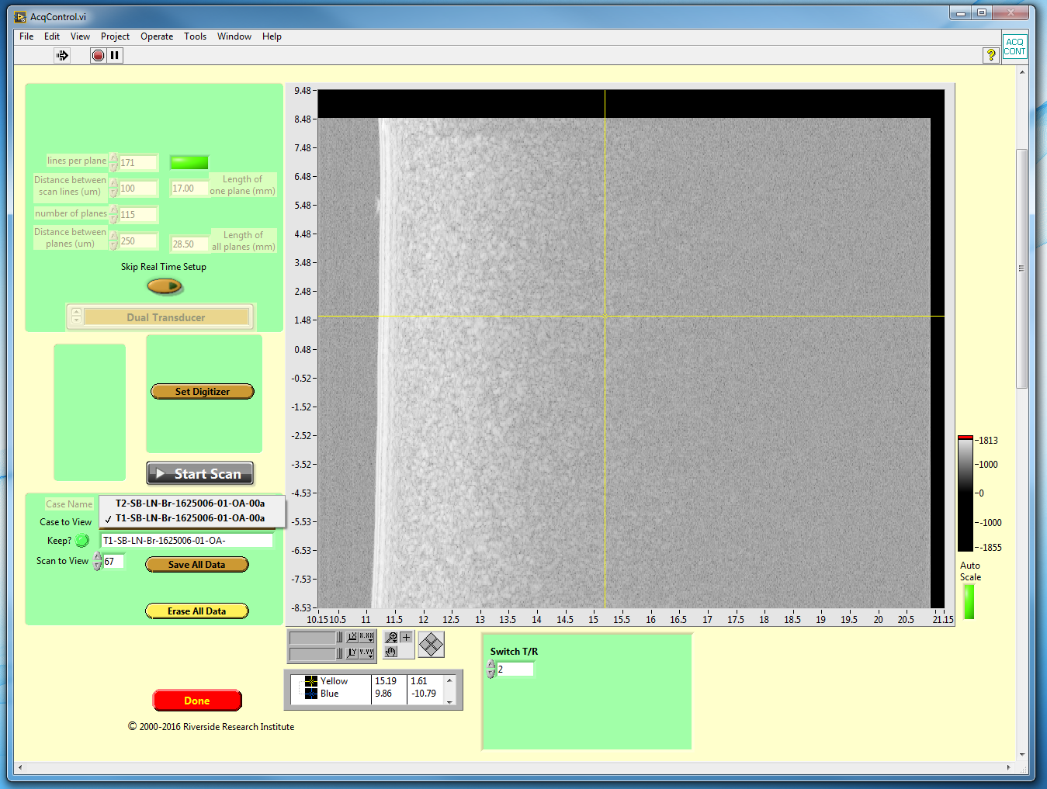

E) Erase Data

Exit

E) Rescale X and Y

C) Scan to View

D) Save Data

A) Start Scanning

B) Case to View

Figure 7: Scan Complete Window

1. Multiple scans can be performed before saving data, but it is better to save as you go to prevent data loss
2. If the data is bad (saturation present or did not collect the correct physical range), click Erase All Data (Figure 7E) and Start Scan (Figure 7A) to begin again
3. Clicking Save All Data (Figure 7D) brings up an interface that allows you to change the save path and/or add comments in the header of the saved files (Figure 8)
4. Push to save (Figure 8A)
5. Once data is saved, the image screen will turn black until another scan is taken.
6. Helpful Hint: from here you will return to tissue placement with a new sample, or proceeded to data transfer and cleanup.

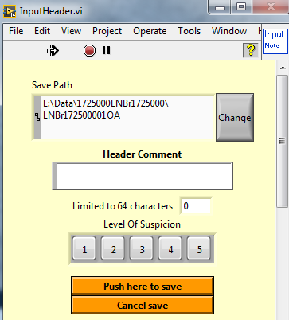

B) Click to Save

A) Mark the Level of Cancer Suspicion

Figure 8: Save Dialogue